<Project Name>

Version <1.0>

[Note: The following template is provided for use with the Rational Unified Process. Text enclosed in square brackets and displayed in blue italics (style=InfoBlue) is included to provide guidance to the author and should be deleted before publishing the document. A paragraph entered following this style will automatically be set to normal (style=Body Text).]

[To customize automatic fields in Microsoft Word (which display a gray background when selected), select File>Properties and replace the Title, Subject and Company fields with the appropriate information for this document. After closing the dialog, automatic fields may be updated throughout the document by selecting Edit>Select All (or Ctrl-A) and pressing F9, or simply click on the field and press F9. This must be done separately for Headers and Footers. Alt-F9 will toggle between displaying the field names and the field contents. See Word help for more information on working with fields.]

Revision History

|  |  |  |  |
| --- | --- | --- | --- |
| **Date** | **Version** | **Description** | **Author** |
| 4/11/2017 | <1.0> | Added Use-case Model | Phy Lieng |
|  |  |  |  |
|  |  |  |  |
|  |  |  |  |

Table of Contents

1. Use-case Model 4

2. Use-case Specifications 4

2.1 Use-case: Add a product to cart 4

2.2 Use-case: Create a new account 5

# Use-case Model

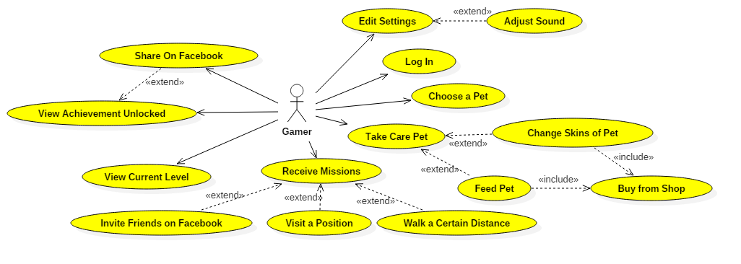

# Use-case Specifications

## Use-case: Log In

|  |  |
| --- | --- |
| Use case Name | Log In Facebook Account |
| Brief description | This use case describes how the Customer can sign in their Facebook Account |
| Actors | Customer |
| Basic Flow | 1. At the homepage, the user click on the facebook icon. 2. If the user have not sign in, the sign in view is shown. 3. User types in ID and password. 4. User press sign in 5. If the ID and/or password is incorrect, a message is shown and return to step 3. Otherwise, the user is log in. 6. If the facebook account haven’t use this app before, a permission is asked. The user accept. |
| Alternative Flows | **Alternative flow 1: User input is wrong (Step 5)**   1. A message is shown. 2. Return to step 2. |
| Pre-conditions | User have not log in facebook |
| Post-conditions | The user successfully log in. |

## Use-case: Run Recording

|  |  |
| --- | --- |
| Use case Name | Run Recording |
| Brief description | This use case describes how the User running process is recorded |
| Actors | Customer |
| Basic Flow | 1. The running process is recorded. 2. If the step counter does not recognize more steps, or not significant number of steps for at least 30 seconds, the session stops. |
| Alternative Flows | **Alternative flow 1: Group Alert**   1. If you are in a jogging group and a member of the group is far away, a notification is sent. 2. After 30 seconds and you remains far away, the group is temporary disbanded. |
| Pre-conditions | When the user step counting increases significantly or velocity is high |
| Post-conditions | Record Running Process. Notification tells how long was the exercise, how many steps, how far did you run and if any mission is finish. |

## Use-case: GPS Reach

|  |  |
| --- | --- |
| Use case Name | GPS Reach |
| Brief description | This use case describes how the game react when the user reach a hotspot |
| Actors | Customer |
| Basic Flow | Check if any missions has accomplished. Changing the missions to finish state. |
| Alternative Flows |  |
| Pre-conditions | GPS was on and the user reaches a GPS hotspot. |
| Post-conditions | Missions’ state may changes. |

## Use-case: Finish Missions

|  |  |
| --- | --- |
| Use case Name | Finish Missions |
| Brief description | This use case describes how a user finish a mission. |
| Actors | User |
| Basic Flow | 1. If you have a mission accomplished, a receive button is shown. 2. The user press the receive button 3. The user receive currency and affection point. 4. The mission change state to reset time to 8 hours. |
| Alternative Flows |  |
| Pre-conditions | Missions(s) are accomplished. User is in mission window. |
| Post-conditions | Missions’ state changes. Currency increases, affection increases. |

## Use-case: Receive Affection Point

|  |  |
| --- | --- |
| Use case Name | Receive Affection Point |
| Brief description | This use case describes how receive affection point affect |
| Actors | User |
| Basic Flow | 1. Increase affection point 2. Calculate and refresh the affection point visual |
| Alternative Flows | **Alternative flow 1: Level Up**   1. If the affection point is enough to level up, player level increases. 2. Receive any bonus from the new level. 3. Update the visual |
| Pre-conditions | One of many ways to receive Affection Point |
| Post-conditions | Affection Point increases. May increase level and receive new bonuses. |